Feb 6, 2016 1:32pm
I am here only to post a summary of everything I have given in regards to the Paradox. This summary is placing the variables in trend/consolidation and how the indicators separate the differences.
Both trends and consolidations have one thing in common and that is with support and resistance. The variable for trends is from high to low and vice-versa. The variable for consolidations is with the swings, and/or sideways. And they both have a support and a resistance.
Because of the variables in trend with this system there is an indicator called “ROMAR”. The second source of the trend is an indicator called “EMA”. These two indicators is the total representation of all supports and resistances within this system; in both trends and consolidations.
ROMAR is the major trend for both support and resistance and crossing EMA changes ROMAR direction of the trend: This is true on all three charts. The 2 hour chart is your primary trend for trading.
EMA is secondary trend according with the swings and changes its trend by crossing Purple.
When you have EMA in a downtrend and ROMAR crosses EMA for the downtrend you then have a true trend. If you have EMA in a downtrend and ROMAR is support you are in consolidation for ROMAR support and vice-versa.
When ROMAR/EMA are running together in the same direction that is your trend until ROMAR and EMA crosses one another; and then ROMAR IS THE ONE reversing the trend.
EMA is your source for short term trend of the swings by crossing Purple. If EMA crosses Purple and becomes resistance and ROMAR is already resistance you are in trend. If EMA crosses Purple and becomes resistance and ROMAR is support; you are in consolidation and vice-versa.
The 4 horsemen: Purple, White, Smooth, and Parabolic’s are dedicated for the swings only; and the Parabolic is the trend for the swings. The swings could be short term or long term depending on ROMAR/EMA. If you get ROMAR/EMA in the same direction with the 4 horsemen then the trend is long term with no swings, but only sliders with retraces back towards the 4 horsemen. With this type of trend the Parabolic is the source on indicating when to close your trade. If the Parabolic is trending above EMA then let the trend ride. It is when the parabolic reaches EMA will the trend end.
In the swings with ROMAR Resistance and EMA as Support or vice-versa; is when you are in consolidation and the swings are short lived. So, during trading you must always have the separation with trend/consolidation as for ROMAR and EMA. This should always be on your trading plan so you can keep reference.
ROMAR:
If you had the 1 hour ROMAR cross its EMA opposite of the 2 hour ROMAR trend - you are then in the first stage of a consolidation and/or reversal. The market behavior on the 1 hour is now under pressure from the trend.
When this happens then the 1 hour is looking for the 2 hour ROMAR crossing. When the 1 hour ROMAR crosses its EMA you are then in opposite trend of the 2 hour which places both the 1 and 2 hour in consolidation and under pressure for a reversal and/or a slider within the 2 hour trend.
This now becomes a much distorted picture and no advance indication of market movement. Or at least it seems so.
The reason for this happening is because of the barriers within support and/or resistance. In this system there are 5 such barriers and they are:
1). 23.6 or 61.8 of the Fibo
2). ROMAR
3). Parabolic
4). EMA
5). 4 horsemen
The first step is to identify the barrier of support and/or resistance in order to trade any further. Now - the issue that some are facing is what charts to look for - with the consolidation - and the answer is this:
All major consolidations are feed off the 2 hour and Daily. If the consolidation occurrence were feed off the Daily and then it affects all the trading charts. All you need to do is wait on the 1 hour support/resistance being in consistence with the 2 hour. The 1 hour sets you up for the 2 hour trend.
In order to understand consolidation lets define the word:
Definition of CONSOLIDATION:
1: the act or process of consolidating: the state of being consolidated
2: the process of uniting: the quality or state of being united; specifically: the unification of two or more corporations by dissolution of existing ones and creation of a single new corporation.
Example of CONSOLIDATION in the market:
"The consolidation of several intelligence agencies into one super agency"
When the market consolidates it is then in submission of changing power from Bear to Bull and vice-versa. Any time we go into consolidation; ROMAR/EMA will show this consolidation period by crossing one another. And all it takes is one of the three charts to reverse from the trend into consolidation.
A SLIDER: The sliders are most frequent in consolidations; especially with the 4 horseman’s. This is when Smooth does not cross Purple but slides over/under Purple (depending on trend) and keeps the swing intact. This is also true with EMA. You can have White/Smooth crossing Purple but EMA does not cross Purple but slides under/over Purple to keep the Swing/Trend intact. And for your longer term trends ROMAR can also slide under/over EMA to keep the trend intact.
VARIOUS CONSOLIDATIONS:
1). Crossings of ROMAR and EMA in changing the trend.
2). Change of trend in one chart from the others.
3). Out of “sync” with charts; such as Swings, ROMAR, EMA, and Parabolic’s.
This is why the market is 80% consolidations.
All these variables stated above makes up the moving Paradox.
This system also has what is known as the consolidated paradoxes trend and consists with the Daily disruption of market exhaustion in regards with the ROMAR crossing EMA and the Market is in between Both ROMAR and EMA with a 50 or less pip spread. This disruption can last a long time within the Daily chart as the Ranging Mode is strictly between the Two: ROMAR and EMA. Variables in indicators can change dramatically from hour to hour; from chart to chart. And frustration can set in as the hours pass by while you are sitting at the computer trying to find a decent trade within the indicators.
This type of disruption can only be solved with trading support and resistance which are: ROMAR and EMA on the Daily chart.
Highs and Lows:
When it comes to highs and lows I do not use the Daily candle as most traders do accept for breaking these levels in my daily trading plan. What I use is the 2 hour lows and highs of the “Fibonacci Retracements” as a marker for previous highs and lows during cycles. The 2 hour Fibo is a great resource for trading; it is accurate and dependable.
You have to always remember the 2 hour is your TREND chart and the 1 hour is your reference for entry with the 2 hour. For a good trade to be established is when the 1 hour 4 horsemen are sync with the 2 hour. In other words; they both are in the same direction. Otherwise you will be counter-trading for a loss.
Feb 6, 2016 3:51pm
All I am doing today is only posting summaries and rules. I am not hear to answer questions; but only give details to help you all:
Rules for Trading
Basic rules:
a: Do not trade against the trend.
b: Trade objectively and not subjectively using support and resistance.
c: Do not chase the market but let the market come to you.
d: The 2 hour chart is your trend chart for the system.
e: The Daily is your reference for the Daily trend, support, and resistance.
Rules for uptrends:
a: ROMAR and EMA must be in sync on all three charts to trade long.
a: The 1 hour is your reference chart with the 2 hour trend chart.
b: You are looking for sync of both ROMAR and EMA uptrend on both the 1 and 2 hour charts to enter a trade.
c: Trades are made from the support area to go long.
Rules for downtrends:
a: ROMAR and EMA must be in sync on both 1 and 2 hour to trade short.
a: The 1 hour is your reference chart with the 2 hour trend chart.
b: You are looking for sync of both ROMAR and EMA uptrend on both the 1 and 2 hour charts to enter a trade.
c: Trades are made from the resistance area to go short.
Rules for consolidation:
a: The 2 hour is your trading/trend chart.
b: Use the Daily Chart S/R as reference for consolidation.
c: You can trade either short or long in consolidation.
d: Trade from resistance to support and vice-versa. Do not trade from center in consolidation.
e: Both upper and lower bands are resistance and support in consolidation.
Rules for Support and Resistance:
a: The 2 hour ROMAR is the Major Support and Resistance for the whole system.
b: The 2 hour EMA is the secondary Support and Resistance for the whole system.
c: The Daily ROMAR is the Major Support and Resistance for the Daily.
d: The 2 hour Fibo determines cycles for high/low support and resistance.
Rules for determining consolidation:
a: If one of the trading charts are not in sync with one another you are in consolidation.
c: If the Daily ROMAR/EMA are not sync with 1 and 2 hour charts you are in consolidation.
d: 10% of the time is trend; 85% of the time is consolidation; and 10% economic news.
Rules for Economic News:
a: Never trade during a MAJOR (Red) economic release.
b: Clean up your trades 5 minutes before a major economic release.
The 8 Rules on Money Management:
There was a lion, a donkey and a fox all keen to go out rabbit hunting together. After a productive day of hunting, the three of them sit around the pile of rabbits and the lion asks the Donkey; "Mr. Donkey, would you please divide the pile into equal shares for the 3 of us? The Donkey obliges and counts the rabbits into three equal piles for each of them. The Lion immediately roared and pounced on him. He then piled all the rabbits on top of the donkey and asked the Fox; "Mr. Fox, would you please divide the rabbits up evenly between us? The Fox takes out 1 scrawny rabbit from the pile and puts it in a pile for himself then say; "There you go, Mr. Lion, that's your pile" pointing to the large pile of rabbits. The lion says; "Mr. Fox, where did you learn to divide so equally"? And the fox says; "The Donkey taught me."
The moral of the story is to learn from others' mistakes.
Rule #1: Never risks any more than you can afford to lose, you will lose money, all traders do; make sure you're not sacrificing anything else important in the process.
Rule #2: Never risk any more than 2% of your margin trading account on a simple trade. For mini account holders, 2% of $300 would be $6 so realistically you would need around $15 so you can make this 5%. As soon as your account size is big enough, make this 2%.
Rule #3: Always use a stop loss order. If you haven't figured out where your stop loss order and limit order should be at the start of your trade then you shouldn't be trading.
Rule #4: Always place your stop order before pulling the trigger.
Rule #5: Know your exit point before you enter a trade.
Rule #6: Demo Trade First: Become successful with a demo when there's nothing on the line before you open a real account.
Rule #7: Take a breather when your equity has taken a dive.
Rule #8: Don't let your emotions call the shots: Stay cool, calm and collected. Patience and a clear head will win the game.
The Dove - Forex Trainer
Feb 6, 2016 4:25pm
Traders are taught through webinars, online e-books, some may even pay for books and other kinds of training outside the norm. But most traders are taught through forums such as FF and being violated with smoking guns from traders that have no education themselves. So these seekers that are in search of fulfilling their desire never reach the threshold of their dreams.
And the reason their dreams are abandon is because they are taught one thing, or one concept without variables; no-matter what system they are taught on. And that concept is used over and over again in every scenario they encounter.
The psychology of trading is not in the trading itself but lies within him/herself. It is the education in which they were taught through past history of trading, and/or, how life is operated since childhood. And this is where the concept had been born; learning vices are greater than virtues. Vice is a habit that spoils ones chances of achieving personal happiness.
To be a highly educated person does not mean you are also virtuously prudence. The prudent man is one who does the good, as opposed to one who merely knows the good with a deficiency or lack of wholeness.
Concepts and Variables are two words that have much meaning and bring one into wholeness. And a prudent trader learns you cannot do one without the other.
The rules of trading are very simple and not hard to remember. The concepts and variables are in line with the rules of trading and are also simple and not hard to remember. The only difference is how you are applying the rules; either objectively or subjectively.
Trading has one concept with three variables; trends, supports, and resistances. Each variable has its own concept and you cannot trade one the same as another. It is impossible to do so.
As I have said in the beginning. I can give you everything you need to become one of successful. But it is up to you, and how you apply yourself with the education if you will become one of the great ones.
The Power of Confluence
What is confluence and why is it so important when trading the Forex market? In this post Im going to discuss what confluence is, why its so important and how you can integrate it into your current trading strategy to help put the odds in your favor.
What is Confluence?
Confluence: a situation in which two things come together or happen at the same time.
Essentially confluence represents two or more things coming together at the same time. In terms of trading, we can say that confluence is when two or more factors come together at the same place on a chart or two different charts.
Examples of these things might be a key support or resistance level, price behavior with buy or sell signal or even something as simple as a strong trend. All of these things form what well call Confluence Factors. In other words a strong trend might be one factor; a price behavior might be a second factor and so on.
Putting the Odds in Your Favor
I think I can be so bold as to say that consistent profits are the goal of every serious trader. So why then do only a small portion of traders make it to this level? It all comes down to the use of confluence. Those traders who can be called consistently profitable have found a way to identify and harness the power of confluence in a way that puts the odds in their favor.
The ability to put the odds in your favor is what trading is all about. Figure out a way to do this over and over again and youll be well on your way to becoming profitable. This is where the combination of various Confluence Factors comes into play. In other words; the more Confluence Factors present on any given setup, the greater the odds are that the setup will move in the intended direction. Even in consolidation placing the Confluence Factor into place is very profitable.
The Dove - Forex Trainer
Feb 6, 2016 4:38pm
Unstructured Environment:
Everyone gets frustrated because of getting into some bad trades for one thing, and also realizing the difficulties of finding trade targets.
There is one MAJOR problem with most traders, if not all, fail coming into terms with and that is operating in an unstructured environment this is the major underlying reason why traders lose and cannot win; or even quit.
In our normal society we conform to rules and laws that govern our lives and those of our fellow citizens. So we learn these rules and conform in using these rules for the safety of our society. But being in a society that operates under an unstructured environment by creating their own rules to live and survive by has its many disadvantages.
So lets take a closer look at the problems associated with operating in an unstructured environment for traders.
It begins by taking responsibility for our actions. This means taking charge of your own destiny as a trader and people in general simply cannot accept this responsibility. They want the comfort of having someone holding their hand and if things go wrong they then have thousands of excuses why. Trading is a business and you have no one to answer too. But like any other business; there are rules accommodating in running their business.
The market is all powerful and shows no mercy because it too operates in an unstructured environment. The market is always right and never wrong and this causes major psychological problems for traders we all hate being wrong. So without rules the frustration becomes the traders worst enemy.
Most traders get frustrated and break the rules, or even create a new set of rules as to enable them a more comfortable environment to trade in and continues to lose. It is called the ends justify the means; trading without discipline. One of the largest factors that separate success from failure is a trader's ability to manage rules that apply to trading. Traders love to run with the pack and listen to other traders opinions when it comes to trading. But this environment is also unstructured with traders that have no concept for rules. Trading without discipline is a journey to the far side of the horizon along with the other 95%.
When you work in such an environment answering to no one then the problem is discipline. You have to build a constructed environment around yourself with rules for trading rules for discipline rules for priorities and rules for commitments. If you do not have this kind of environment then you will always be a loser.
And right now you are seeing the outcome of this unstructured environment; not only with yourself - but also with the market.
The only way to become a winner is applying yourself to an environment that desperately needs to be changed. And you, as individuals, are the only ones that can make the changes.
If you know it or not --- this is the problem and has nothing to do with your trading. If you change your environment then you will change everything else in being successful. In other words; it begins by stepping out of your comfort zone and broadening your vision.
The Dove - Forex Trainer
Feb 6, 2016 4:52pm
The Fear Factor:
Market knowledge and ability to understand chart analysis with this system will only get you so far in Forex trading. Wagering huge volumes of money in a market as susceptible to change is liable to cause a whole range of opposing emotions; fear, excitement and anxiety just to name a few. Battling against your emotions in order to complete a successful deal is one of the major hurdles, which must be overcome if you are to become a trader able to close huge deals and earn vast sums of money. If you can overcome or even use these emotions to make trades on the Forex then a successful career may be beckoning, but failure to do so will almost certainly cost you a substantial amount of money and end any lingering desires to progress in the busy world of Forex trading.
Initiating and closing a trade at the right times (in the moment) are the backbone of becoming a successful trader. If a person cannot execute these deals at the right times, the psychological and financial damage can be crippling. Missing a huge trend or sitting too long on a good entry, can be a demoralizing experience, but one that you will encounter during a career in Forex trading.
Entering at the right time is just one thing that must be done correctly, but if you are unable to leave at the right time or hold your nerve during the course of the trade, the implications are potentially severe. For example; accepting a small loss just before the market rises can lead to a horrendous huge profit/loss ratio margin. Similarly sitting on a currency that is plummeting for too long could be financially crippling. Understanding the Forex market and having faith in your ability to judge a trend will pay dividends if you hold your nerve, backing out at the wrong time can prove to be a catastrophic misnomer.
The fear generated by investing your own personal money is the main thing that must be overcome. It is the culprit in so many failure stories, people who just couldn't overcome their anxiety investing unwisely, pulling out at the wrong time, missing a rise completely, all result in failure and are caused by fear. Accepting this fear and using it to your potential will make you a stronger trader, able to trade freely and enjoy the thrill of the exchange. Fighting it will get you nowhere, understanding and overcoming it are the best remedies to this baseless emotion.
Trading plans will help you ride out the rough times and capitalize on the good ones. Sometimes just taking a step back and accepting a few losses will give you the energy and the knowledge to attack the Forex with renewed vigor, and make some serious profits. Accepting that sometimes you will lose out, you need to be able to take the hits and roll with a punch, there are no guarantees in the trading market, so being able to move on and start again is a skill that is paramount to generating success.
You must first master these things, and be able to correctly interpret the figures that are represented in order to spot the trends and make your move. And this all means nothing if you don't have the courage of your convictions; if you are too afraid to buy and not sure when to sell then a glittering career in market trading is likely to elude you. The trend is your friend and it means nothing if you firstly can't spot it and secondly don't have the courage to back it. Knowledge, Understanding, Wisdom and overcoming Fear is the 4 best ways to unlock the door of becoming a successful trader. Without all 4 you will more often than not become unstuck; so prepare, practice and evaluate everything before taking the plunge in the complicated world of Forex trading.
OK Traders I leave you and may God bless us all.
The Dove - Forex Trainer

Feb 8, 2016 12:25pm

There are some of you flip-flopping between support and resistance and not paying attention at all.
Basic rules:
a: Do not trade against the trend.
b: Trade objectively and not subjectively using support and resistance.
c: Do not chase the market but let the market come to you.
d: The 2 hour chart is your trend chart for the system.
e: The Daily is your reference for the Daily trend, support, and resistance.

What does rule e: say? And what does this Daily screen-shot below say?
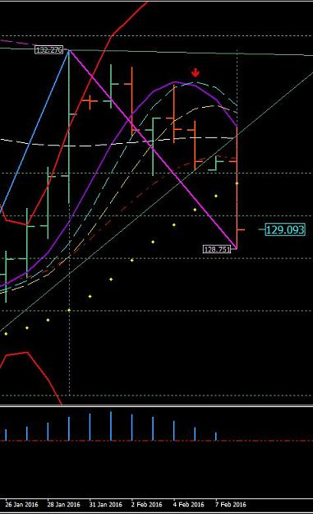

It says Purple,White, and Smooth is RESISTANCE. That it is what it says. It also says EMA is SUPPORT of not crossing Purple yet. It also says that both ROMAR/EMA is the Trend RESISTANCE - DOWNTREND.
What does this 2 hour screen-shot below say?
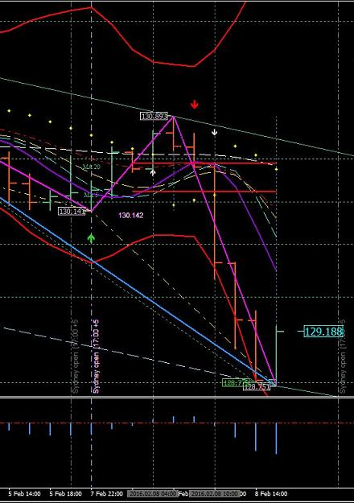

Very clearly - ROMAR had crossed EMA of yesterday's opening for the DOWNTREND. And "IF" you was creating a daily trading plan you would had seen the Daily chart Purple hit was entry with the opening below EMA support retracing to Purple Resistance. ALL THREE CHARTS ROMAR/EMA ARE IN THE DOWNTREND.
The Dove - Forex Trainer

Feb 9, 2016 12:38pm

What is sad is when a trader will defeat himself. What rule I have stated is the greatest of them all? That RULE is "trading in the moment". And all I have seen from posting to posting is traders all over the charts trying to figure out how to get into a trade. That is sad because there hasn't been one posting in the moment.
First thing you have is the FIBO showing the bottom and flipped for the up on all three charts; and not one posting indicating this very fact.
Secondly you have all three charts in downtrend with ROMAR, on each chart, above EMA for the downtrend.
Thirdly - you are all trading the 1 hour chart instead of the 2 hour trend.
Rules after rules are being broken.
With the Fibo's up and the ROMAR's down - you are in consolidation. But the major reason for consolidation is the Daily EMA. The Daily EMA is still support in not crossing the Daily Purple as of yet. And one trader did mention that fact. And here is the Daily showing that fact:

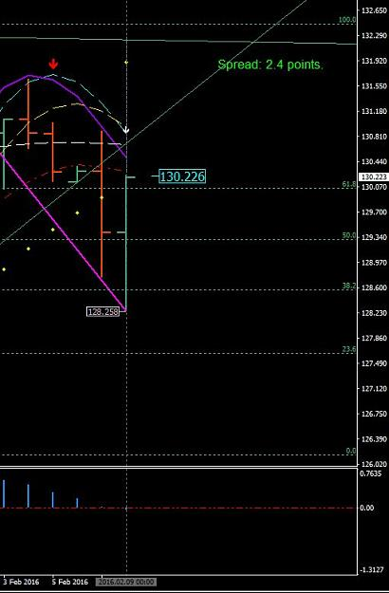

Now lets take a look at yesterday's opening. Two hours after the opening you had an open candle below Purple WITH THE 1 HOUR. To eliminate the risk factor you wait for the open below Smooth for entry and the reason is because the 2 hour trend is still in the downtrend. At entry you had the Purple/White crossing Purple, below Smooth, and the Parabolic was eliminate as support for a 40 pip trade.
The 2 hour was showing this fact by opening below the EMA resistance.
This is one trade since opening.
The second trade you had was with the 1 hour EMA crossing Purple for the uptrend with the 4 horsemen.
But the 2 hour was consolidating for the swing and the Parabolic was also an issue of being stopped for a long entry. And name of the game is called PATIENCE.
With patience you wait on the 1 hour for the 2 hour retrace in consolidation and take the hit off the 1 hour 4 horsemen; which was also the 2 hour White/Purple crossing for entry for another 40 pips to the 2 hour ROMAR.
With the 1 hour White/Purple crossing and the opening above EMA was also an entry; but because of the 2 hour consolidating you would had to wait on the 2 hour before getting into profit. If you get into the right trade your 40 stop will never be hit.
If you do not trade in the moment you will NEVER find your entry. And that is with a PERIOD.

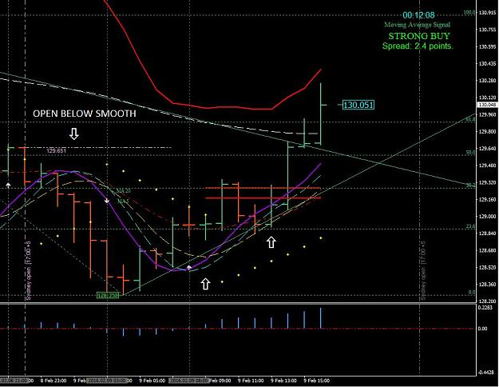

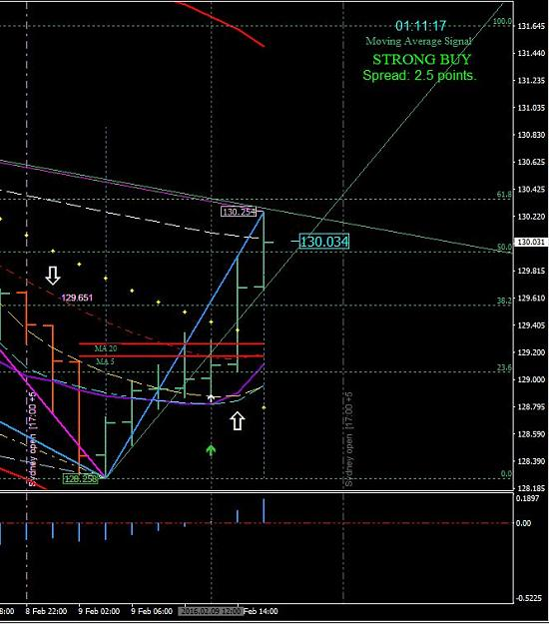

The Dove - Forex Trainer
Feb 9, 2016 12:49pm
arya.aryaee
Then by your explanation i found out your rules are float . and the day plan is not so important and we could take position against day plan also.

 dove_alliance
Quoting arya.aryaee
Then by your explanation i found out your rules are float . and the day plan is not so important and we could take position against day plan also
And that is one of your problems. Because a daily plan will had shown what is happening in the market and you would had the first entry on your plan if it was made at the opening. If the plan was made during London - then it would had shown the second entry at that time. The rules do not float but are set in stone.
The Dove - Forex Trainer
Feb 9, 2016 1:09pm
arya.aryaee
Quoting dove_alliance
What is sad is when a trader will defeat himself. What rule I have stated is the greatest of them all? That RULE is "trading in the moment". And all I have seen from posting to posting is traders all over the charts trying to figure out how to get into a trade. That is sad because there hasn't been one posting in the moment. First thing you have is the FIBO showing the bottom and flipped for the up on all three charts; and not one posting indicating this very fact. Secondly you have all three charts in downtrend with ROMAR, on each chart, above...
this is your yesterday post#1762 :
"what does this Daily screen-shot below say?It says Purple,White, and Smooth is RESISTANCE. That it is what it says. It also says EMA is SUPPORT of not crossing Purple yet. It also says that both ROMAR/EMA is the Trend RESISTANCE - DOWNTREND." and
this is your today post:
"But the major reason for consolidation is the Daily EMA. The Daily EMA is still support in not crossing the Daily Purple as of yet."
may please explain what has been changed in ROMAR/EMA combination of yesterday in compare to today?

Feb 9, 2016 1:18pm
 dove_alliance
Quoting arya.aryaee
{quote} this is your yesterday post#1762 : "what does this Daily screen-shot below say?It says Purple,White, and Smooth is RESISTANCE. That it is what it says. It also says EMA is SUPPORT of not crossing Purple yet. It also says that both ROMAR/EMA is the Trend RESISTANCE - DOWNTREND." and this is your today post: "But the major reason for consolidation is the Daily EMA. The Daily EMA is still support in not crossing the Daily Purple as of yet." may please explain what has been changed in ROMAR/EMA combination of yesterday in compare to today?
Nothing has changed accept in your prospective. You haven't yet learned the difference between support and resistance between ROMAR and EMA. Still the same today as it was yesterday in regards to the Daily. All you need to do is get rid of your old school of thinking and see things in a different light.
The Dove - Forex Trainer
Feb 9, 2016 2:25pm
arya.aryaee
Quoting Contrax
Just Saying.. If Dana nevers says anything of H1... everyone should be Focus in H2..... but Dana says, use H1 for reference and H2 for Trading.. everyone is using H1 for trading....
Dove post#20:
"The Paradox System has 3 charts; 1 hour, 2 hour, and the Daily. You do not need any chart below the 1 hour, or above the Daily. The 1 hour is your trading chart. The 2 hour is reference in changing of trends. The Daily is reference for long term trend and reference with support and resistance."

 dove_alliance
Quoting arya.aryaee
{quote} Dove post#20: "The Paradox System has 3 charts; 1 hour, 2 hour, and the Daily. You do not need any chart below the 1 hour, or above the Daily. The 1 hour is your trading chart. The 2 hour is reference in changing of trends. The Daily is reference for long term trend and reference with support and resistance." #paradox#
That was the first post in giving reference as for the charts -- but you forget the rest of it:
"If you follow the rules and not be looking for short-cuts you can become a very successful trader with the Paradox, and no longer need to be here on the FF forum; or any other form for that matter. The greatest rule for trading is in the moment; and the moment means - trading one bar at a time. Not what happened yesterday, or a year ago, not even the last bar. But on the 2 hour candle bar that is moving. That 2 hour candle is the actual Moment candle and you have 2 hours to trade it. This is not an over-night success as it takes time to learn how to trade in the moment. So be looking at 6 months of your time in learning to trade in the moment. If you give yourself time with patience you can trade the Paradox with at least 80+% weekly profits."
The Dove - Forex Trainer

